TEMPERATURE DEPENDING ELECTROLUMINESCENCE BRIGHTNESS WAVES OF THE ZNS: MN THIN-FILM ELECTROLUMINESCENT DEVICES

Dr. Rameshwar Tiwari,
Assistant Professor
Department of Physics
Govt. Penchvalley PG College Parasia, Dist. Chhindwara (MP) INDIA

Nitendra Kumar Gautum
Assistant Professor
Department of Physics
Govt. Penchvalley PG College Parasia, Dist. Chhindwara (MP) INDIA

Abstract-The aim of our paper is to study the electroluminescence brightness wave of ZnS: Mn thin-film EL devices and discusses the brightness wave of effect of frequency. To date, least studies have been made on the EL brightness waves of thin-film EL device. We have found that as expanding temperature of the EL device, the brightness wave diminishes.

Keybords-Electroluminescence, Photomultiplier, scillogram, space charge, memory effect, storage effect.

INTRODUCTION
The majority of EL data is based on the average output from heterogeneous crystal assemblies, each of which has a non-uniform response to the uniform field. It has been observed that this averaged response, of course, appears either less or more complex than that of a single EL spot. There is a dependence of the brightness of emission and its spectral contents on the applied frequency of excitation and also on the shape of the waveform.
A detailed work regarding the time average measurements has been carried out by Waymouth and Bitter (1954). The curve showing emitted light as a function of alternating field, for one complete cycle, is known as brightness wave. Electroluminescence produces light that is not steady but flickers at double the frequency of the applied field.
On the application of alternating field to the EL cell, the brightness wave does not become steady at once but some transient effect may be observed, and after a short interval the pattern becomes steady. The structure of the EL cell also influences the wave pattern. If the cell has a symmetrical structure, a simple waveform is obtained, and for asymmetrical structure the waveform shows secondary peaks. The secondary peaks in brightness waves may also seem on both the ascending and the descending aspect of primary peaks.
Zalm (1956) observed that the amplitude of the secondary peak decreases as the applied voltage increases. However, for ZnS:Cu,Mn phosphors, at very low high temperature, the secondary peak has not been observed (Thornton 1956, Mattler 1956).
Temperature affects the amplitude and location of the secondary peak. The Mattler (1956) and Haake (1957) observed shifts in secondary peak continuously from descending side of one primary peak to ascending side of the next primary when temperature is decreased, Similarly, shifts of the secondary peak has also been observed by many workers (Patek 1959, Hahn and Seeman 1995). Thornton never observed a secondary peal on the ascending side of the primary peak.

EXPERIMENTAL METHOD
For the measurement of EL brightness waves in thin-film EL devices, the EL device was prepared for the thin-film electroluminescence with a critical concentration of activator for which there is intense EL emission. The photomultiplier output was connected across a resistance of 10 k and the voltage developed across the resistance was fed to one channel of a Unitek 0D10 dual trace oscilloscopes. With the help of an attenuator, the output of the wide band amplifier was reduced by ten times, and the attenuator's result was taken care of into the oscilloscope's subsequent channel. Subsequently, the brightness wave could be followed for various voltage and frequencies of the applied electric field. The test game plan used to find the brightness waves is displayed in Fig.1.
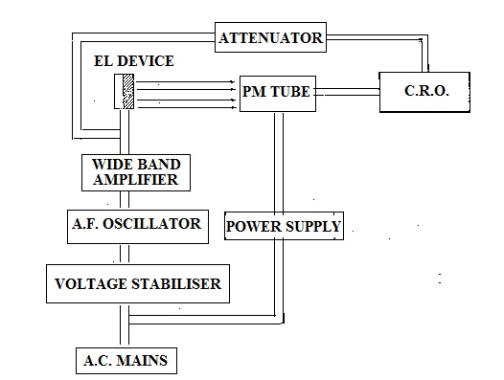
Fig. 1. Experimental arrangement for determining the EL brightness wave

RESULTS
Fig.2. Show how the temperature affects the EL brightness wave in ZnS:Mn based EL devices and if increasing temperature of the EL device, the brightness wave decreases.

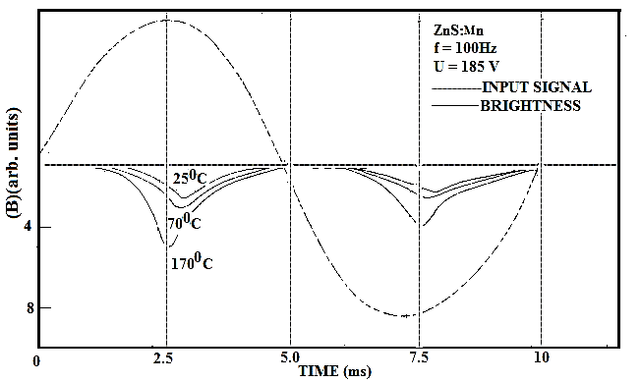
Fig. 2. Variation of EL brightness waves of ZnS:Mn (1000 ppm) with temperature

CONCLUSION
The creation of space charges is responsible for the asymmetry in the brightness peaks. A positive space charge causes an expansion in the field at the cathode, which lifts free transporter infusion, though a negative space charge causes the current infused at the cathode connection point to diminish.
The brilliance of a thin film EL device with a twofold protecting layer structure is significantly impacted by the extremity of the pulse voltage when it is driven by a progression of voltage pulse. At the point when the extremity of the pulse is modified, the device shows a wonderful measure of light. Conversely, assuming the extremity of the following pulse is something very similar, the splendor estimated is shockingly low. Hance, this thin film EL device can be considered as having data stockpiling. Under ordinary room light, the memory impact endured a couple of moments, however it stayed over 10 hours when the device was kept in obscurity.
A strong electric field is generated by the voltage pulse, when electrons are accelerated in the active ZnS:Mn film. Those electrons invigorate the luminous centres as they go through the active layer. After going through the active layers, electrons store at the edges between dynamic layer and insulating layer, outside which they are not allowed to infiltrate. Even after the electric field is withdrawn, these electrons stay at the interface for a long time (storage effect).
The successful internal field across the dynamic layer is compacted by the superposition of earlier polarization if the polarity of the succeeding pulse is the same as that of the previous pulse, resulting in charge polarization across the active layer. If the polarity of the successive pulse is inverted, then, additive polarization increases the inner field (polarization effect). As a result, the polarity of the succeeding pulse affects the device's light emission or output brightness.
The phase difference between peaks of applied voltage and brightness wave decreases with increasing temperature of the EL device. The successful internal field across the dynamic layer is compacted by the superposition of earlier polarization.

V. REFERENCES
- J.F.Waymouth and F. Bitter, “Experiments on Electroluminescence”, Phys. Rev.,Vol. 95, p. 941-949, 1954,
- J. Mattler, “Evolution des ondes de brillance en electroluminescence sousl'effet du champ et de la temperature”, J. Phys. Radium, Vol. 17 (8-9), p. 725-730, 1956.
- P. Zalm, “The electroluminescence type phosphors”, Philips Research Rept., Vol.11, p. 353-357, 1956.
- W.A. Thornton, “Electroluminescence in Zinc Sulfide”, Phys. Rev., Vol.102(1), p.38-46, 1956
- C.H. Haake, “Secondary Wave of Electroluminescence”, J. Appl. Phys., Vol.28 (1), p. 117-123, 1957
- J. Patek, “On the photo-electroluminescence of ZnS-Cu”, Czecholovak J. Phys., Vol. 2 (1), p. 161-167, 1959

